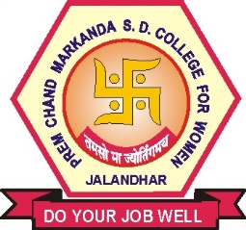

PCM S.D. COLLEGE, JALANDHAR
Alumni Feedback Form

Name: Ms./Mrs. …………………………… Age (Years) .………………………..

Class/Course …………………………… Session …………………………

Occupation …………………………… Contact No. …………………………

Tick the appropriate column of your choice :

S.No. | Particulars | Strongly Agree | Agree | Strongly Disagree | Disagree
1 | I feel proud to be the student of S.D. College. | 61.8% | 38.2% | - | -
2 | The learning in the S.D. College Jalandhar is useful in my career. | 58% | 41.5%
3 | The developments in the S.D. College Jalandhar over the years are appreciative. | 50.9% | 48.1% | 0.5% | 0.5%
4 | The new courses introduced meet contemporary requirements. | 38.7% | 60.4% | 0.5% | 0.5%
5 | S.D College Jalandhar is involving alumni in its activities. | 38.2% | 59.4% | 0.9% | 1.4%
6 | The alumni have a role to play in financially strengthening the S.D. College Jalandhar further. | 36.8% | 60.4% | 2.8% | -

Suggestions for future improvement …………………………………………………………

…………………………………………………………………………………………………….

